**-- 1) WRITE A QUERY TO DISPLAY PRODUCT NAME AND SUPPLIER**

select product_name,supplier

from products

join purchases

on products.id = purchases.supplier_id

join suppliers

on purchases.supplier_id = suppliers.id;

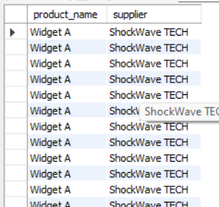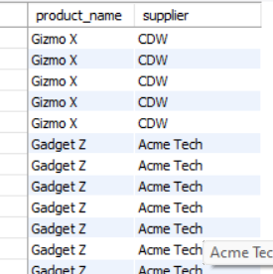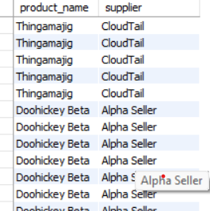

**-- 2) WRITE A SQL QUERY FOR NAME OF TOP SELLING PRODUCT**

SELECT (product_name),SUM(number_shipped) AS TOTAL_SHIPPED

FROM orders

JOIN products

ON orders.product_id = products.id

JOIN purchases

ON products.id = purchases.product_id

group by products.product_name

ORDER BY SUM(number_shipped) DESC;

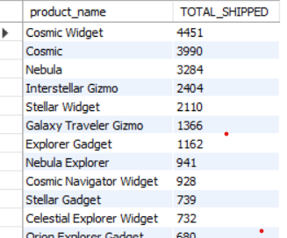

**-- 3) WRITE A SQL QUERY FOR TOP SELLER SUPPLIER NAME**

select supplier,sum(number_shipped) AS total_shipped

from orders

join products

On orders.product_id = products.id

join purchases

on purchases.product_id = products.id

join suppliers

on suppliers.id = purchases.supplier_id

group by suppliers.supplier

order by sum(number_shipped)desc;

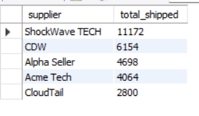

**-- 4) PRODUCT WISE SUM OF NUMPER SHIPPED**

SELECT product_name,SUM(number_shipped)

FROM products

JOIN orders

ON products.id = orders.product_id

GROUP BY product_name

order by sum(number_shipped) desc;

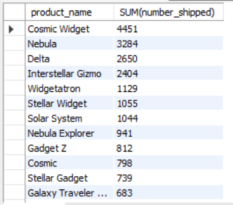

**-- 5) SUPPLIER PURCHASES INVENTORY RECEIVED**

SELECT supplier,SUM(number_received)

FROM suppliers

JOIN purchases

ON suppliers.id = purchases.supplier_id

GROUP BY supplier

ORDER BY supplier;

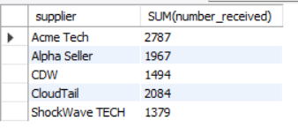

**-- 6) TOTAL INVENTORY RECEIVED FROM SUPPLIER**

SELECT supplier,SUM(inventory_received)

FROM products

JOIN purchases

ON products.id = purchases.product_id

JOIN suppliers

ON purchases.supplier_id = suppliers.id

GROUP BY supplier;

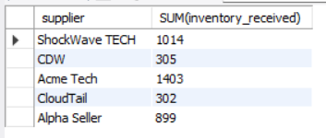

**-- 7) PRODUCT WISE SUM OF NUMPER SHIPPED**

SELECT product_name,sum(number_shipped)

FROM products

JOIN orders

ON products.id = orders.product_id

GROUP BY product_name

ORDER BY sum(number_shipped)desc;

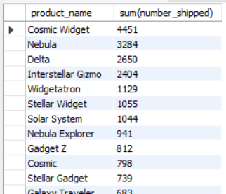

**-- 8) CROSS JOIN**

SELECT * FROM suppliers

CROSS JOIN purchases

ON purchases.supplier_id = suppliers.id;

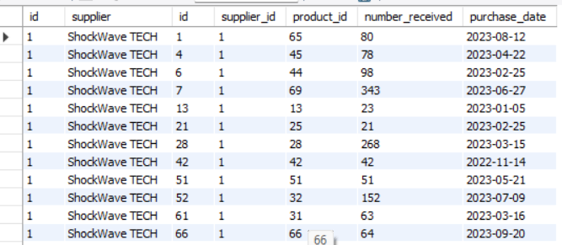

**-- 9) CUSTOMER FIRST NAME, LAST NAME , PRODUCT BUY FROM WHICH SUPPLIER**

SELECT first_name,last_name,product_name,supplier

FROM orders

JOIN products

ON orders.product_id = products.id

JOIN purchases

ON products.id = purchases.product_id

JOIN suppliers

ON purchases.supplier_id = suppliers.id;

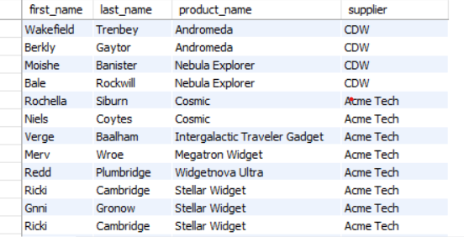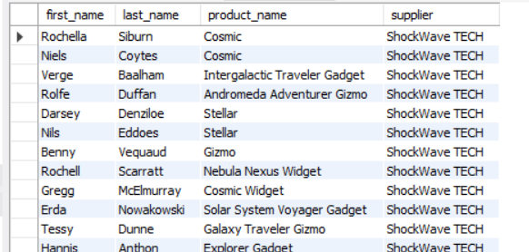

**-- 10) LAST 180 DAYS ORDER WITH PRODUCT NAME,FIRST_NAME,LAST_NAME**

SELECT order_date,product_name,first_name,last_name

FROM orders

JOIN products

ON products.id = orders.product_id

WHERE DATE_SUB(curdate(),INTERVAL 6 MONTH)<= order_date

ORDER BY order_date desc;

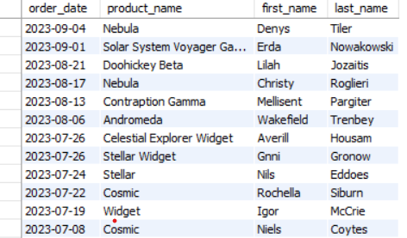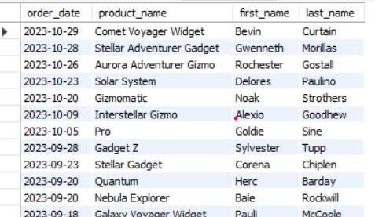

**-- 11) PRODUCT NAME RECEICED FROM SUPPLIER ,INVENTORY HOLD AND ORDER SHIPPED**

SELECT product_name,SUM(INVENTORY_RECEIVED),SUM(NUMBER_RECEIVED),SUM(NUMBER_SHIPPED)

FROM products

JOIN purchases

ON products.id = purchases.product_id

JOIN orders

ON products.id = orders.product_id

GROUP BY product_name

ORDER BY product_name DESC;

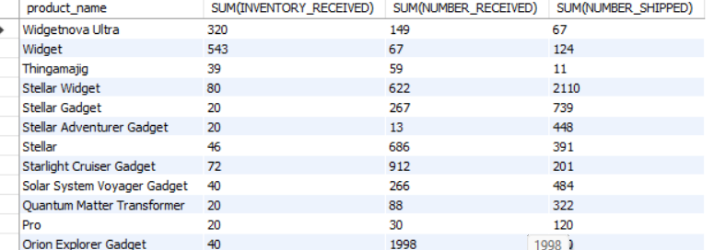

**-- 12) SUPLLIER SHIPPED ORDER**

SELECT supplier,SUM(NUMBER_SHIPPED)

FROM suppliers

JOIN purchases

ON suppliers.id = purchases.supplier_id

JOIN products

ON purchases.product_id = products.id

JOIN orders

ON products.id = orders.product_id

GROUP BY supplier;

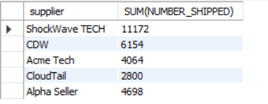

**-- 13) FIND STARTING INVENTORY AND NUMBER SHIPPED AS PER PRODUCT NAME**

SELECT product_name,SUM(STARTING_INVENTORY),SUM(NUMBER_SHIPPED)

FROM products

JOIN orders

ON products.id = orders.product_id

GROUP BY product_name;

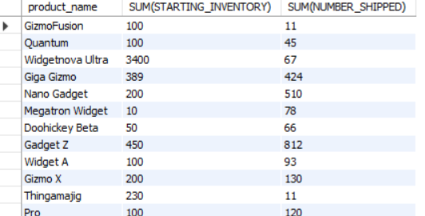

**-- 14) PRODUCT NAME,INVENTORY ON HAND SUPPLIER WHO HAS Stellar Gadget IN STOCK**

SELECT product_name, supplier, SUM(INVENTORY_ON_HAND)

FROM products

JOIN purchases

ON products.id = purchases.product_id

JOIN suppliers

ON purchases.supplier_id = suppliers.id

WHERE PRODUCT_NAME = 'Stellar Gadget'

GROUP BY supplier;

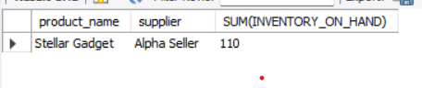

**-- 15) FIND HIGHEST PRODUCT SHIPPED TO CUSTOMER NAME = Benny**

SELECT product_name,first_name,SUM(NUMBER_SHIPPED)

FROM products

JOIN orders

ON products.id = orders.product_id

WHERE first_name= 'Benny'

GROUP BY product_name;

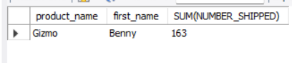

**-- 16) NUMBER SHIPPED TO CUTOMER DETAILS YEAR AND MONTH WISE**

SELECT YEAR(order_date) AS YEAR,MONTHNAME(order_date) AS MONTH,COUNT(number_shipped) AS TOTAL_ORDER

from orders

GROUP BY YEAR(order_date),MONTHNAME(order_date)

ORDER BY YEAR(order_date),MONTHNAME(order_date) ASC;

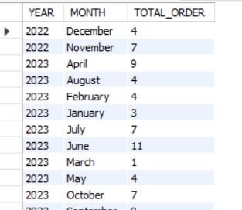

**-- 17) LEFT JOIN ON 3 TABLES**

SELECT product_name,supplier

FROM products

LEFT JOIN purchases

ON products.id = purchases.product_id

LEFT JOIN suppliers

ON purchases.supplier_id = suppliers.id;

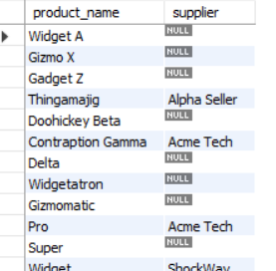

**-- 18) Sub-Query In Puchase Table Find Avg of Number_received and > than avg NUMBER REVEIVED**

SELECT * FROM purchases

WHERE NUMBER_RECEIVED > (SELECT AVG(NUMBER_RECEIVED) FROM purchases);

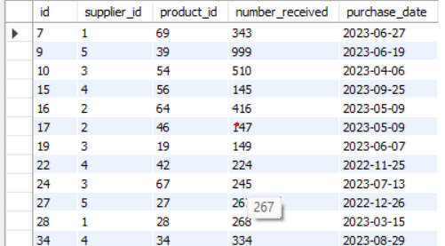

**-- 19) USING WHERE CONDITION**

SELECT first_name,number_shipped

from orders

WHERE number_shipped > 20;

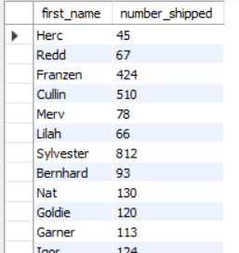

**-- 20) JOIN THE PRODUCTS AND ORDERS TABLE USING CROSS JOIN QUERY**

SELECT * FROM products

CROSS JOIN orders

ON products.id = orders.product_id;

